Experiment-25
Program:
import cv2
import numpy as np
# Read main image
img = cv2.imread("watch.jpg")
gray = cv2.cvtColor(img, cv2.COLOR_BGR2GRAY)
# Read template
template = cv2.imread("template.jpg",0)
# Apply edge detection
img_edges = cv2.Canny(gray,50,150)
template_edges = cv2.Canny(template,50,150)
w,h = template.shape[::-1]
# Template matching
result = cv2.matchTemplate(img_edges,template_edges,cv2.TM_CCOEFF_NORMED)
min_val,max_val,min_loc,max_loc = cv2.minMaxLoc(result)
top_left = max_loc
bottom_right = (top_left[0]+w, top_left[1]+h)
cv2.rectangle(img,top_left,bottom_right,(0,255,0),3)
cv2.imshow("Detected Watch",img)
cv2.waitKey(0)
cv2.destroyAllWindows()
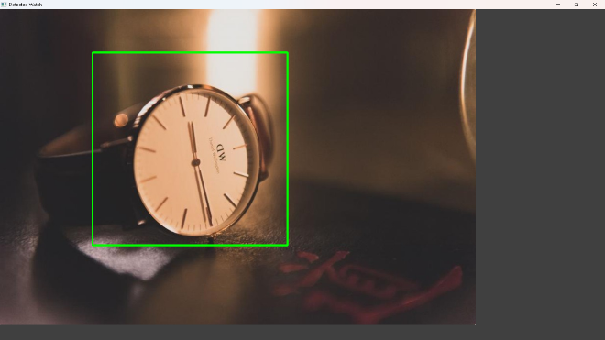
Output:

